American Indian
College Fund

Community awareness grants

for STUDENT GROUPS & INSTITUTIONS

april 2020 to august 2020

Application Deadline: March 16, 2020, 5:00 P.M. MST

Contact Information
David Bledsoe
Student Engagement & Communications Manager
Phone (720)214-2566
Email: dbledsoe@collegefund.org

American Indian College Fund
8333 Greenwood Blvd.
Denver, CO 80221
1-800-776-3863
Fax: 303-426-1200
www.collegefund.org

Five Month Grant Opportunity

“Think Indian” was originally created as a public awareness campaign to promote the American Indian College Fund, and the many ways that its scholars contribute to, and change our world.
Its message connected so deeply with Native students and institutions that it was revived in 2018, specifically to promote the College Fund’s scholarship, and other student programs.

The American Indian College Fund has created a grant program to highlight its “Think Indian” campaign, and scholarships program for Native students. The grants are intended to encourage institutions who serve Native students to promote the positive message of “Think Indian,” the vibrancy of Native students, and the highlight the support provided by American Indian College Fund scholarship programs in their campus and community. Projects must engage or include Native students.

Student groups and institutions can use grant funds for any activity or project that will promote the College Fund’s “Think Indian” campaign and scholarships in their community. Programs can include, but are not limited to:

- Informational, social or artistic events
- Art displays, installations or murals
- Music performances or video screenings
- Local awareness, publicity or marketing campaigns
- Online/social media campaigns
- Participation in existing campus or community events
- Themed volunteer or service events (including Native vote or census projects)

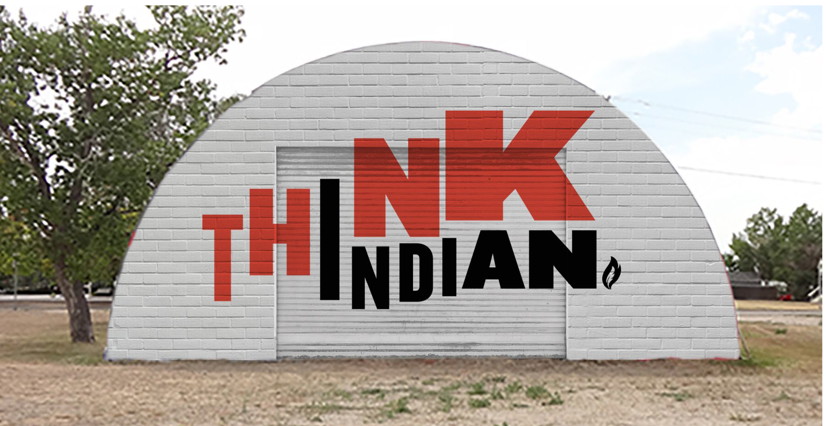
Because awareness is a focus of this grant, successful proposals and planning need to include predicted attendance, viewers, participants or media coverage. Inclusion of print, online and video documentation of grant activities is also essential in reporting.

Guidelines

Submissions must include the signature of a student faculty supervisor, or staff supervisor, as well as the project coordinator responsible for oversight of the grant program.

Grantees will be awarded up to $2,500 per grant period. Awarded institutions will develop community awareness programs that will be implemented during the grant period. Project activities MUST be implemented and completed during the duration of the grant period.

Institution Eligibility Requirements

In order to apply for this grant, the institution must meet the following eligibility requirements:
- Nonprofit, accredited, institution of higher education with an existing program specifically serving native students, or a current and full member of the American Indian Higher Education Consortium
- Proposed programs or activities must promote the positive message of “Think Indian,” the vibrancy of Native students, and the support provided by Native scholarship programs. The project must include or engage Native students.

Evaluation of Applications

Applications will be evaluated by an internal selection committee comprised of American Indian College Fund staff based on the following elements:

- Clarity, completeness and quality of application
- Quality and impact of proposed use of monetary award
- Proposed activities meet the project goals
- Proposed project can be accomplished within project time period
- Plan to measure and evaluate project

Grant Application/Award/Reporting Schedule

Deadlines for applications submissions and reports will be updated each grant period. Deadlines and report due dates for the April 2020 to August 2020 grant period are listed below:

Application & Selection

March 16, 2020 - Completed applications along with project budget and timeline must be received by 5:00 P.M. MST at the American Indian College Fund. Applications should be sent to dbledsoe@collegefund.org.

March 23, 2020 - Selected grantees will be notified by electronic notification.

March 27, 2020 - Signed grant agreement letter is due (electronically) to the American Indian College Fund by 5 pm MST.
March 31, 2020 – Grantees must participate in a conference call with the Program Officer.

Grant and Award Timeline

March 30, 2020 – Grant awards will be sent to the grantees.

April 1, 2020 to August 30, 2020 - Implementation of grant activities; ongoing evaluation throughout the grant period.

Reporting

BY September 30, 2020 – Project evaluation reports are due to the American Indian College Fund NO LATER THAN THIS DATE via email to dbledsoe@collegefund.org.

Applicant Information

Date Submitted

Tribal College or University Information
Submitting Tribal College or University
Mailing Address
City: |  | State: | Zip Code:
Telephone Number: |  |  | Fax Number:

Authorized Institution Supervisor Information
Name
Title
Email Address
Telephone Number

Project Administrator Information
Name
Title
Email Address
Telephone Number

Institution Authorization
I hereby authorize submission of this application to the American Indian College Fund’s Community Awareness Grant Program:

Authorized Institution Supervisor (Name, Title & Signature): Date:
President if at Tribal College

Project Administrator (Name, Title & Signature): Date:

Project/Activity Information
Name of proposed Community Awareness Project/Activity:
Total Amount Requested
Proposed Project Period |  | State Date: |  |  | End Date:
Please select type of activity you will be hosting:
Information Event |  |  |  | Social Event
Art Event/Display |  |  |  | Music Performance
Film/Video Screening |  |  |  | Ad/Marketing Campaign
Online/Social Media Campaign |  |  |  | Volunteer/Service Event
Number of participants that you anticipate will participate in the proposed academic courses and/or community extension activities?
Students |  |  |  | Community Members
Institution Staff
What outcomes and impact do you hope to achieve with the project/activity selected? Describe awareness and impact for students, community, faculty/staff, and institution.
Describe your plan for raising awareness of your proposed project/activity on your campus and/or community?
Which audiences will you reach out to, and how will you effectively connect with them?
Which campus and/or local media will you reach out to, and how?
Which institution officials, and/or local community leaders do you plan to invite, involve, or request recognition from? How will you include or engage Native students?

Grant Proposal Instructions
This opportunity provides awards up to $2,500 per grant period. Institutions must meet stated eligibility requirements to apply. In addition, the project must demonstrate its effectiveness and impact in raising community awareness of Native students and scholarship support.
- Proposed Grant Plan and Description
  - Proposal Narrative

The proposal narrative should give a description and plan for the activities that will be funded by the requested grant – which groups will be targeted and how outcomes will be measured.

  - Project Biographies

Please include a short bio of the project/activity coordinator on the project, and any other participants. Include their experience and qualifications related to the project.

- Goals, Objectives and Milestones

Please fill out the following template Goals, Objectives and Milestones.
Goals: Your desired goal or result to which the project will contribute.
Objectives: What the project is expected to deliver and how will you fulfill and achieve your goals.
Milestones: Project milestones are used to manage the project work effort, monitor progress and results of your stated objectives, and report significant checkpoints to achieving your goal. Example: Raising awareness of Native students across ALL campus populations.
A minimum of two goals must be submitted – you may choose to add more.
Goal 1: |  | Milestones
Objective 1:
Objective 2:
Objective 3:
Goal 2: |  | Milestones
Objective 1:
Objective 2:
Objective 3:
Goal 3: |  | Milestones
Objective 1:
Objective 2:
Objective 3:

- Timeline

Please provide a timeline of activity/s that will be conducted to support the initiative of the grant. Your project timeline should reflect your project description. The project timeline must fall within the April 2020 to August 2020 grant period.

Goal 1:
Activities and  Milestones | April |  |  |  | May |  |  |  | June |  |  |  | July |  |  |  | August |  |  |  | Responsible Party
 | 1 | 2 | 3 | 4 | 1 | 2 | 3 | 4 | 1 | 2 | 3 | 4 | 1 | 2 | 3 | 4 | 1 | 2 | 3 | 4

Goal 2:
Activities and  Milestones | April |  |  |  | May |  |  |  | June |  |  |  | July |  |  |  | August |  |  |  | Responsible Party
 | 1 | 2 | 3 | 4 | 1 | 2 | 3 | 4 | 1 | 2 | 3 | 4 | 1 | 2 | 3 | 4 | 1 | 2 | 3 | 4

Goal 3:
Activities and  Milestones | April |  |  |  | May |  |  |  | June |  |  |  | July |  |  |  | August |  |  |  | Responsible Party
 | 1 | 2 | 3 | 4 | 1 | 2 | 3 | 4 | 1 | 2 | 3 | 4 | 1 | 2 | 3 | 4 | 1 | 2 | 3 | 4

- Budget
Please provide an itemized budget with categories of expenditures that will be funded by the requested grant. Your budget will account for any expenditure that the project will incur during the grant period. In addition, will any other funding sources or matching dollars support the program or activities? The budget must be spent within the April 2020 to August 2020 grant period.

Project Expense |  |  |  |  | Total
Materials/Supplies
Name of Item | Description | Estimated Cost X #
 |  |  | X
 |  |  | X
 |  |  | X
 |  |  | X
 |  |  | X
 |  |  | X
 |  |  | X
Marketing
Name of Item | Description
Advertising
Postage
Printing
Other
Project Total

- Reporting
At the conclusion of your Community Awareness program or activity, a final report must be submitted. The final report format will include the following: a report cover sheet, a narrative of the program, evaluation and outcomes of the completed activity, and any attachments such as photos, video, activity or media coverage. The final report will be due on BEFORE September 30, 2020 (via digital submission).

Application Check List/Required Documents
Applicants must submit the following documents to receive full and equal consideration:

Application with authorizing signatures
Project information
Grant proposal (summary and description)
Timeline, itemized budget, goals, objectives and milestones

Complete applications must be received electronically by 5 pm MST on March 16, 2020.

Email application to dbledsoe@collegefund.org
David Bledsoe, Student Engagement & Communications Manager
American Indian College Fund, Student Success Services
8333 Greenwood Blvd.
Denver, CO 80221

